Scottish County Moth Recorder Voucher Photo Archive

Purpose
The initiative’s primary purpose is to create a validated archive of Voucher photographs of Scottish moths. These are held, by Vice County, in the Photos section of the group's site. The Vice County albums are either CMR albums or Proposed albums. The former can only be updated by the CMR in question and is the validated voucher archive. Individuals can upload images to Proposed folders.

Although the site is here for all Scottish CMRs it isn't supposed to be a Scotland-wide photo display. It is there to provide somewhere to put photographic evidence that a species has been recorded at a local VC level. It may be appropriate to have multiple photos of the same species that are recorded only every few years. Really it is there so that a CMR’s successor or their successor when they see a record in the VC database has somewhere to go to satisfy themselves that a record is sound.

Archive location and Dropbox setup
The archive is currently hosted on Dropbox. Dropbox is a file hosting service operated by Dropbox, Inc that offers cloud storage, file synchronization, and client software. To use the archive, recorders will need to register (for free) with Dropbox.
The Dropbox archive is owned, currently, by Mark Cubitt as Moderator. Individual vice county folders can be shared to other people for update or just for viewing. If you want access for either purpose then please contact the Moderator. The moderator will invite you to share a folder via an email from Dropbox. This email has a link to “View Folder” which you should click.
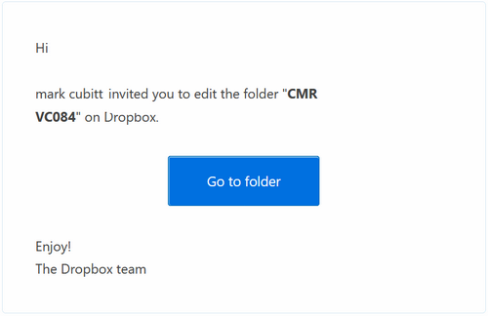
If you are not already registered with Dropbox then you will be presented with a webpage to provide your name, email address and a password.
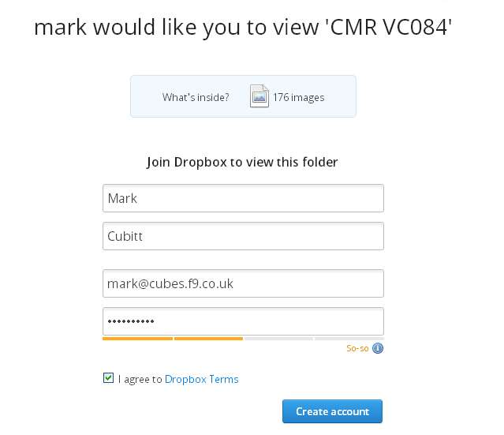
If registering then you will be given the option to download the Dropbox application (which I would recommend). The installation program guides you through the installation process and setup. Just take the default options about folder location.
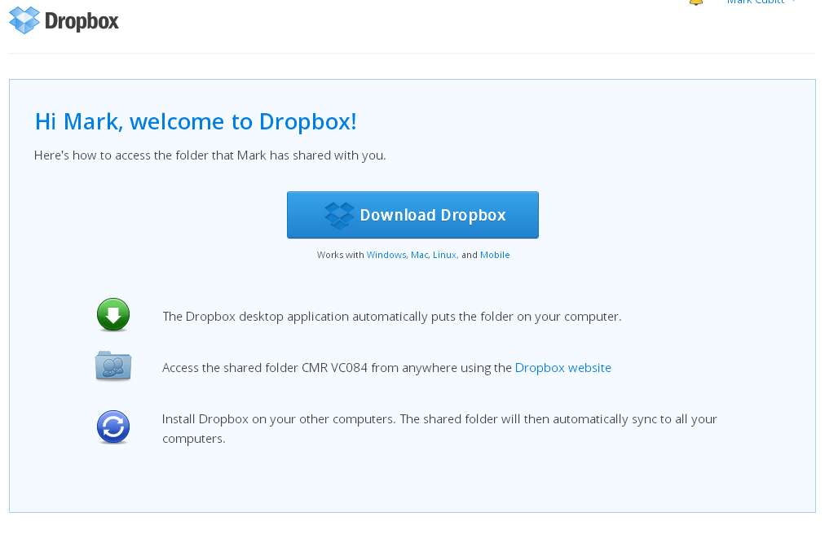

VC folders
A VC can have two folders. The verified VC voucher photo archive shall be called “CMR VCxxx” where the xxx is the vice county number (with a leading zero for VCs with numbers less than 100). This album will only be updated to by the CMR. A second folder for the VC is one where others can upload a photo to propose it to the CMR. This album will be called “Proposed VCxxx”.

Voucher Photo Naming
Photos should follow this naming convention:
code species_name (reared) location vc date observer_name.ext
e.g. 73.279 Broad-barred_White Faucheldean_Bing_NT0874 84 19May2001 GFitchett.jpg.
- Please use leading zeroes for the ABH code and date elements.
- A space character should separate each data item in the name. Please ensure that only a single space is used as double spaces indicate an extra (empty) field!
- The data items should not contain spaces or full stops so either just delete the spaces or use underscores in place of any spaces.
- The date should not include spaces, full stops or / characters, should have the month as the first three alphabetic characters and use a four digit year.
- If there are two photos of the same species on the same date then add a _2 to the end of the species name e.g Seraphim_2.
- The location can be a place name, grid reference or both (again without spaces). It maybe appropriate to use a vague location for sensitive species or sites as the archive photos maybe open access.
- The observer_name should be that of the recorder found in the NMRS database (not the photographer).
- The (reared) element is optional for comments. It can be used where the photograph is of a moth that has been reared from an egg laid by a trapped moth (Progeny) or from a pupa (exPupa) or larva (exLarva). Alternatively comments on a moth’s sex can be held here. Comments must also not contain spaces.
- Plus (+) and percent (%) characters should not be used.

Uploading photos
Voucher photos can be uploaded and managed through the Dropbox web site or, optionally, a Dropbox application allows users to create a special folder on a PC, which Dropbox then synchronizes with the Dropbox servers. Managing the files through the folder on a PC is probably the most straightforward approach.

If the Dropbox application is installed on a PC then files can be saved (or copied) to the Dropbox CMR VCxxx folder on your PC. These files will then be automatically synchronised to the Dropbox service. Files can be deleted or renamed as required.
If using the Dropbox web site https://www.dropbox.com/home then there is an ‘Upload’ icon on the web page to allow photos to be added to the appropriate folder.
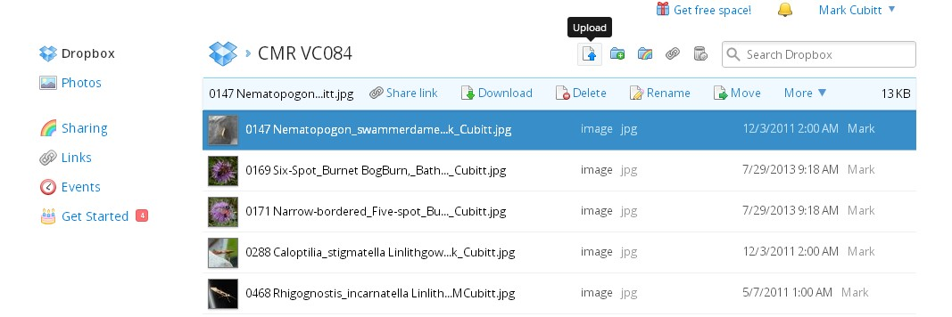

Photos can be deleted or renamed easily by ‘right mouse button’ clicking on the filename.
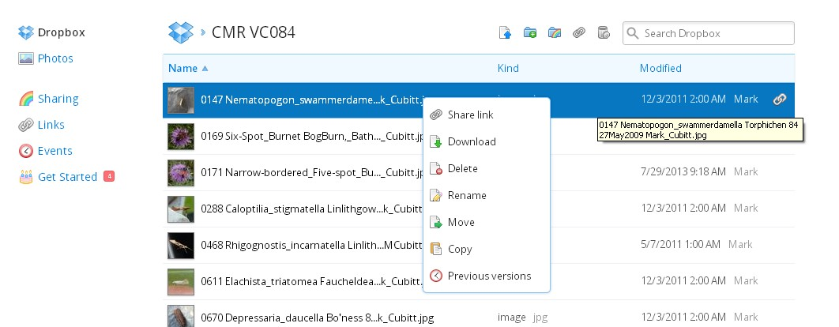

Photo composition
All photos should be unambiguously of the species involved. In some cases, especially for micros, this will involve including a photo of a gen. det. Photos should be cropped so as to maximise the size of the moth’s image. An example is:
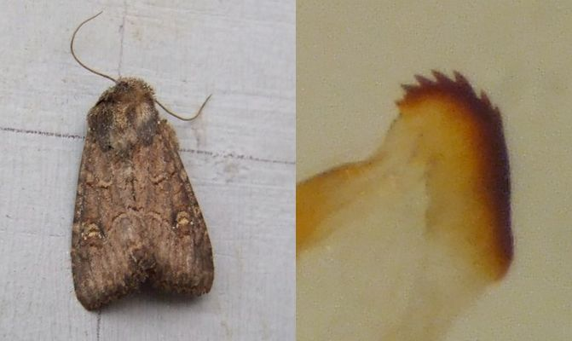

Photo sizing
In order to facilitate the backup process the volume of data to be backed up will need to be kept to reasonable proportions. CMRs are requested to store photos with a file size of about 100-150KB. This typically means about 600 - 800 pixels across. Using jpg compression with the large dimension pictures is helpful and setting this to about 50% to keep the file size down without noticeably losing any quality. If your photo editing software does not allow the quality of jpg to be set then save the file with a 600 pixel size and the moderator will handle the file as required. (See the appendix at this end of this document for instructions on how to do this with some free software.)

Data security
It is important that the voucher photographs for a vice county are those, and only those, that that VC’s County Moth Recorder has verified. Each VC will have a “CMR VCxxx” folder which is a ‘Personal’ folder and so only that VC’s CMR (and the group moderator) can upload files into that folder.
The archive will be backed up periodically to provide protection against Dropbox failing or being withdrawn. The moderator will therefore be able to recover files if accidentally deleted if the CMR wishes.
Dropbox does keep previous versions of files and even deleted ones for a period of time.

Changing CMR for a VC
The VC folders can just be shared with the incoming CMR. This can be done by the Group Moderator or the CMR.

Viewing the Voucher Archive
The DropBox Archive can be viewed from this link <https://www.dropbox.com/sh/dg8zlvjiek84tu5/z-G0yzZv8x>.
Alternatively, the archive is published to the East Scotland Butterfly Conservation website.

Mark Cubitt
Group Moderator
vouchers@eastscotland-butterflies.org.uk

Appendix – sizing and compressing Images

A number of image processing software application can crop, size and compress jpg images. Here the use of the free photofiltre software is described.

The first thing to do with a photo is to crop as much background as reasonably possible from the image. To do this use the selection tool and click and drag your mouse to create a rectangle containing the moth. From the Image menu click on Crop.
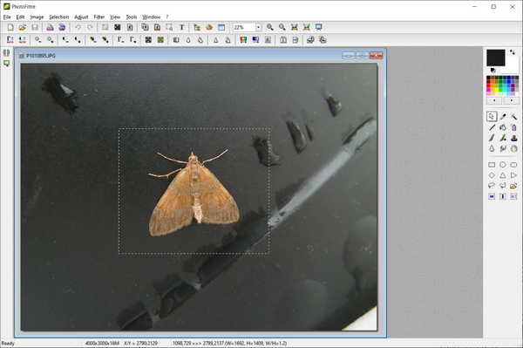

Then size the image using the Image menu and "Image Size" function and choose something like 600 for the width if portrait or 800 if landscape.
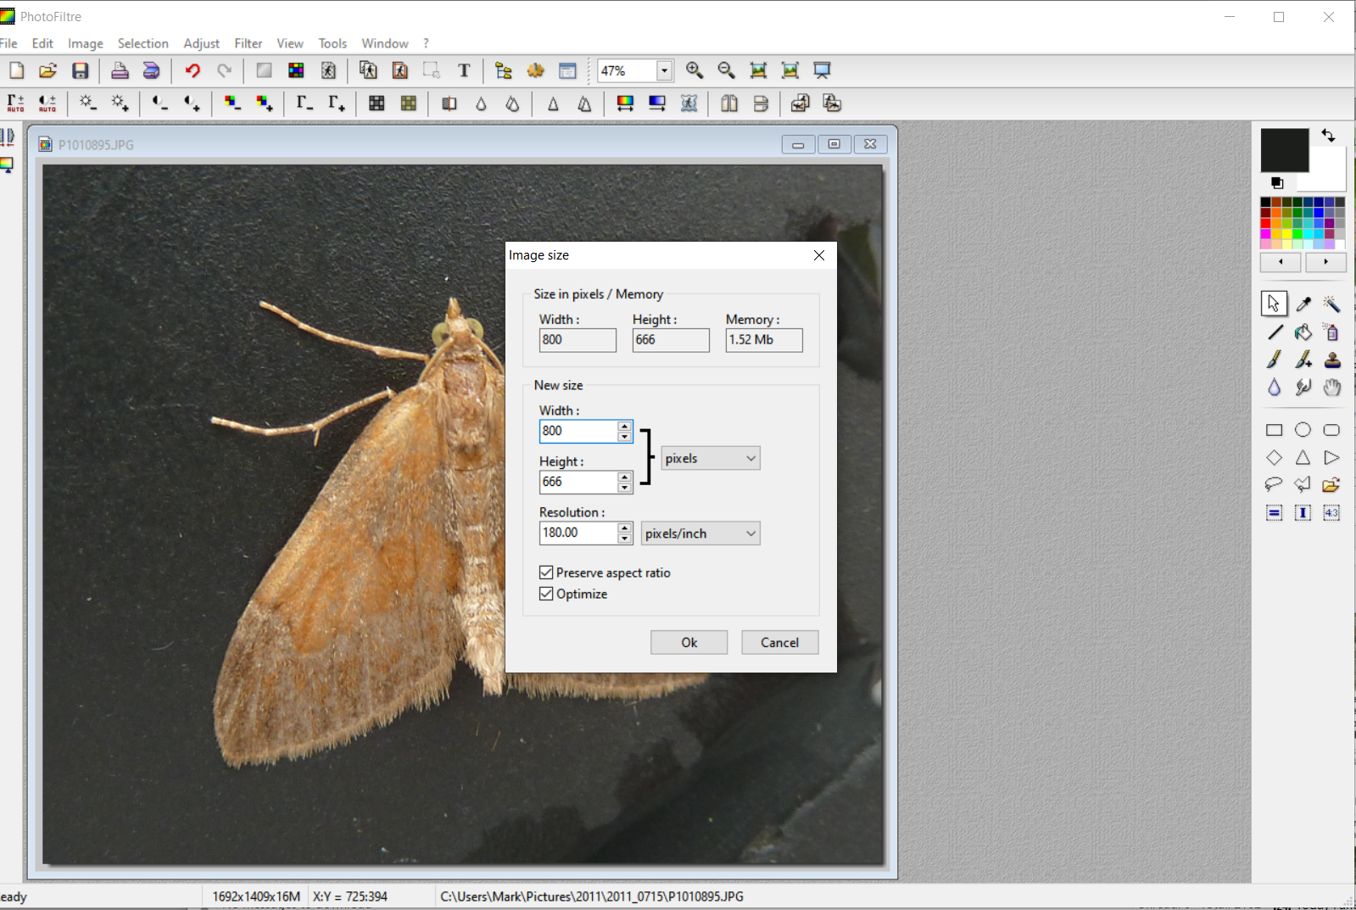

The use File> Save As and save the file as a jpg. You will be given a Compression / quality option when doing this. Set this to 50%.


